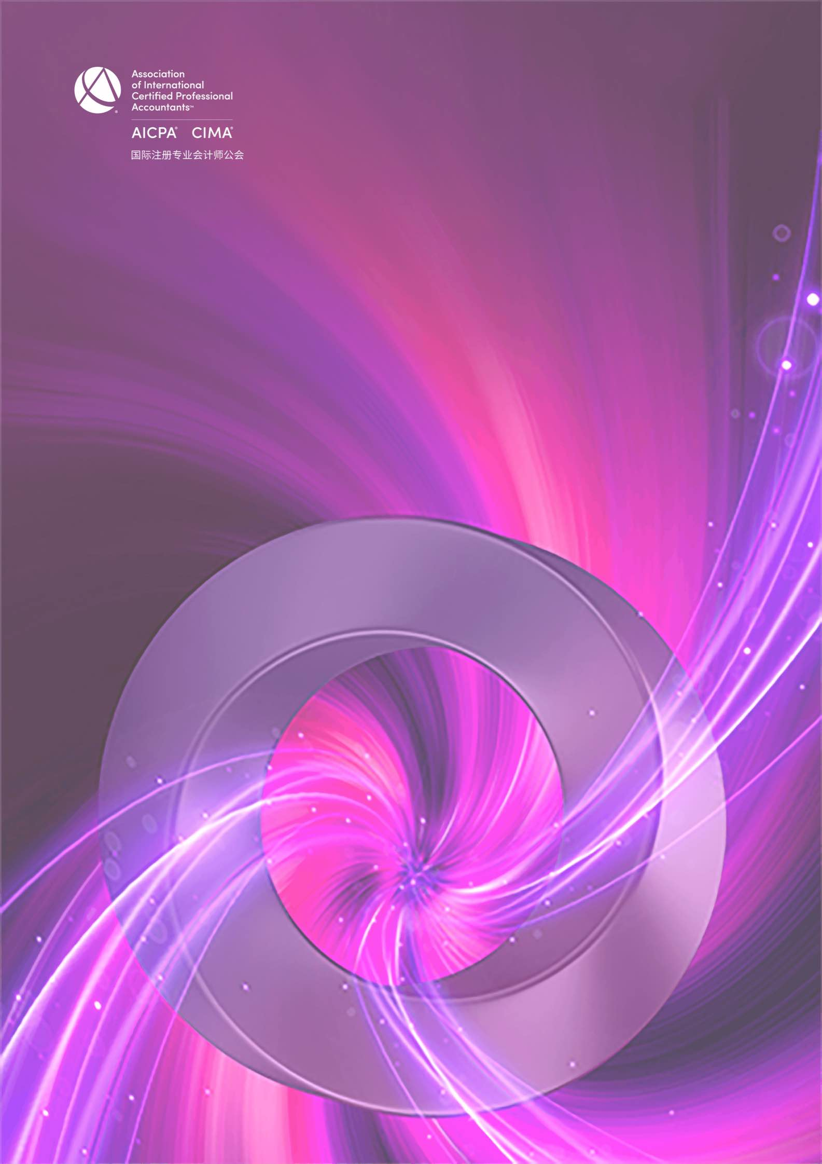

CGMA全球管理会计2021年度中国大奖 最佳管理会计实践申请表

CGMA Best Practice of Management Accounting of the Year 2021 Application Form

This award recognizes the finance team and celebrates the achievements which demonstrated how well the innovation and practice of management accounting has contributed to the overall success.
本奖项授予在中国市场运营的企业财务团队，表彰该团队在管理会计的创新与实践方面的优异表现。

The team provides influential suggestions and drives to make decisions and implement strategies. It plays a key role in assessing the financial status and risks and maintaining the continuous development of the business. Through digital technology and data analysis, it aims to drive the accomplishment of the organization's overall strategy.
通过提供有影响力的建议、驱动对战略做出决策和贯彻，并在评估企业财务状况和风险方面发挥着关键作用。
同时通过数字技术和数据分析，积极推动组织整体战略的达成。

Application form
申请表

Company name
参评公司
Contact person
填表人姓名
Job title
填表人职位
Contact details
联系方式(电话、邮箱)

Note: Each written answer should be completed in no more than approximately 400 words in English and
Chinese respectively.
注意：以下每个问题的回答请控制在 400 字以内 (须以中英文双语回答)

- Please demonstrate how your team communicating insightful information that is influential to drive better decisions on strategy and its execution at all levels?
请说明你们的团队如何通过沟通有价值的信息，提供有影响力的建议，驱动对战略做出更好的决策，并全方位贯彻?

- Please demonstrate how your team actively manage relationships and resources so that the ﬁnancial and non- ﬁnancial assets, reputation and value of the organization are protected?
请说明你们的团队如何积极维护各种关系和资源，使组织的金融和非金融资产、声誉和价值得到保护？

- Please demonstrate if your team simulate different scenarios that demonstrate the cause-and-effect relationships between inputs and outcomes. How did your team analyze information and evaluate opportunities and risks along the value generation path?
请说明你的团队是否通过模拟不同场景，分析投入和产出之间的因果关系 ? 如何按价值创造的路径来分析和评估
机会和风险?

- Please describe how management accounting create values for your organization.
请陈述管理会计如何助力您的组织创造价值？

- Please demonstrate a best practice case of management accounting in your organization.
请举一个你所在组织的管理会计创新的案例。

- Please describe your team’s information and digital literacy from the perspective how your team utilize digital technology and data analytics to support overall data strategy and planning.
请说明您的财务团队是否具有一定的信息和数字素养，你们是如何运用数字技术和数据分析来支持组织的整体数字战略和规划的？

Declaration
I hereby certify that the information given in this entry form is correct and that I am willing to provide supporting documentation, if requested, to verify the information provided.
申明
我在此申明以上所提供的信息都是准确的，如评委会需要，我可以提供相关的文档以供核实。

Name:  姓 名 |  | Position:  职 位
Signed:  签 字 |  | Date  日 期 :

Rules of Entry
参赛规则
- Each entry can attach one relevant profile for judge’s reference.
每位参选人可提交一份附件供评委参考

- Each entry must be submitted on a fully completed application form in both English and Chinese.
每位参选人必须提交一份完整的中英文申请表

- The judges' decision will be final and no correspondence will be entered into before or after the judging
process.
评委会的决定为最终决定，在评委决定过程前后不得有任何通信联系

- The application form should be submitted online by uploading at https://awards2021.cncima.com before the closing date of 17:00 (Beijing time) on 22nd October 2021.
申请表请于2021年10月22日下午5点（北京时间）之前通过 https://awards2021.cncima.com
点击“在线提交”完成提交。

Information provided within this application form may be used by the Association to meet the objectives of CGMA Annual Awards to promote the success and achievements of ﬁnancial professionals in China.
请允许本公会在 CGMA 全球管理会计 2021年度中国大奖颁奖典礼上使用您申请表中的信息，以推广中国财务人才的成功。
Please tick here if you do not wish information provided to be used for communication purposes ( □ media release,
□ interviews, □ marketing materials).
请选择你不希望您的信息出现在以下哪类宣传资料中（ □新闻稿 □访谈 □市场推广资料）

