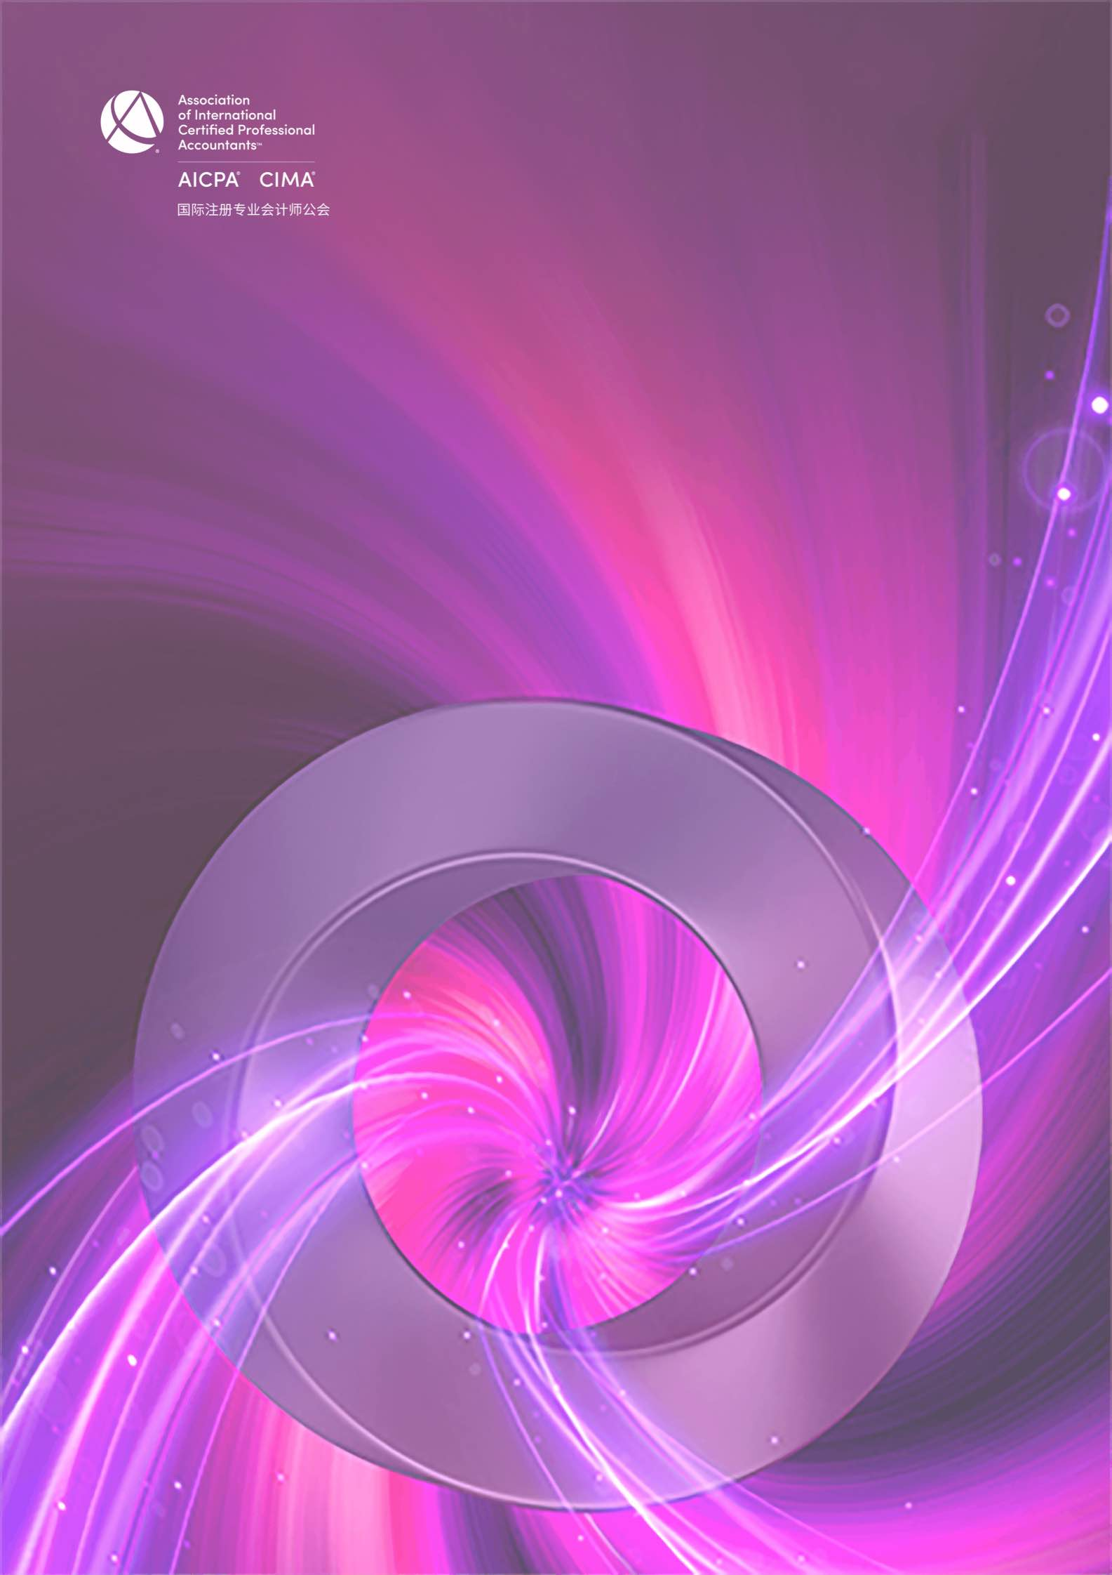

CGMA全球管理会计2021年度中国大奖
最佳共享服务中心申请表

CGMA Best Shared Service Center of the Year 2021 Application Form

This award recognizes an outstanding shared service center operating in the Chinese market. It celebrates the achievements of a shared service center that has demonstrated the values that the SSC has brought to the organization, continuously optimizes the overall performance level of the organization and has been a key factor of the success of the whole organization.
本奖项授予在中国市场运营的卓越共享服务中心，表彰该共享服务中心为整个企业在改善组织职能部门的效率与效用方面带来的价值，不断优化企业的整体绩效水平，进而推动企业的整体成功。

Application form
申请表

Company name
参评公司
Contact person
填表人姓名
Job title
填表人职位
Contact details
联络方式(电话、邮箱)

Note: Each written answer should be completed in no more than approximately 400 words in English and
Chinese respectively.
注意：以下每个问题的回答请控制在 400 字以内 (须以中英文双语回答)

- Please demonstrate how the SSC has contributed to improve the efﬁciency and effectiveness of your function
department.
请说明共享服务中心是如何改善了你所在组织整个职能部门的效率与效用？

- Please describe what impacts the implementation of SSC had on your company, or in what ways has the SSC improved the overall performance of your company?
请说明共享服务中心对于贵公司产生了哪些影响？怎样帮助提高了公司的整体绩效水平？

- Please demonstrate your training scheme to cultivate talents for the SSC and/or for the whole organization.
请说明你们是如何为共享服务中心乃至整个企业培养人才的？

- Please describe how other business units are rating your services? Quotes and endorsement from your customers will be a plus.
请说明其他业务部门是如何评价你们的服务的？客户的支持与感言将为您的申请加分。

Declaration
I hereby certify that the information given in this entry form is correct and that I am willing to provide supporting documentation, if requested, to verify the information provided.
申明
我在此申明以上所提供的信息都是准确的，如评委会需要，我可以提供相关的文档以供核实。

Name:  姓 名 |  | Position:  职 位
Signed:  签 字 |  | Date  日 期

Rules of Entry
参赛规则
- Each entry can attach one relevant profile for judge’s reference.
每位参选人可提交一份附件供评委参考

- Each entry must be submitted on a fully completed application form in both English and Chinese.
每位参选人必须提交一份完整的中英文申请表

- The judges' decision will be final and no correspondence will be entered into before or after the judging process.
评委会的决定为最终决定，在评委决定过程前后不得有任何通信联系

- The application form should be submitted online by uploading at https://awards2021.cncima.com before the closing date of 17:00 (Beijing time) on 22nd October 2021.
申请表请于2021年10月22日下午5点（北京时间）之前通过 https://awards2021.cncima.com
点击“在线提交”完成提交。

Information provided within this application form may be used by the Association to meet the objectives of CGMA
Annual Awards to promote the success and achievements of SSC professionals in China.
请允许本公会在 CGMA 全球管理会计 2020年度中国大奖颁奖典礼上使用您申请表中的信息，以推广中国共享服务人才的成功。
Please tick here if you do not wish information provided to be used for communication purposes ( □ media release,
□ interviews, □ marketing materials).
请选择你不希望您的信息出现在以下哪类宣传资料中（ □新闻稿 □访谈 □市场推广资料）

