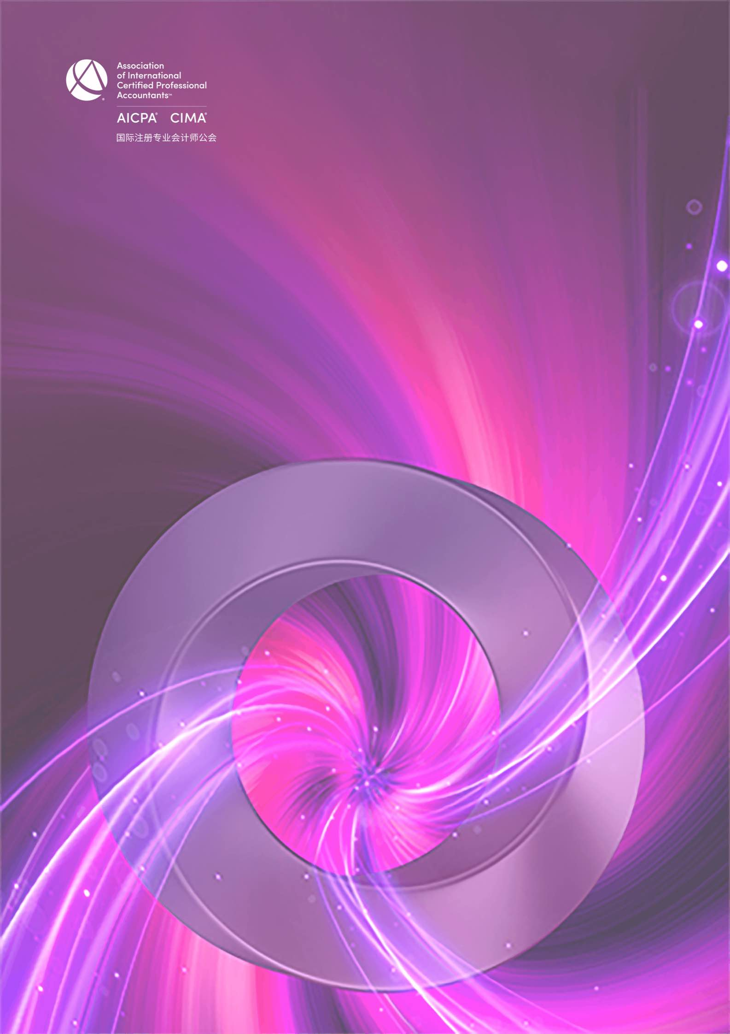

CGMA全球管理会计2021年度中国大奖
最佳机器人流程自动化实践申请表

CGMA Best Practice of RPA of the Year 2021
Application Form

This award recognizes the top RPA initiative in the industry, it celebrates the positive impact and performance improvement brought to the entire organization. Through the RPA project, successfully drives the construction of the organization’s management accounting system, which in turn contributes to the overall success of the organization foundation.
本奖项授予行业内顶尖的机器人流程自动化项目，表彰通过该新兴技术项目的部署，为整个企业带来的积极影响和绩效的提升, 并成功推动企业管理会计体系的建设，进而为组织的整体成功奠定了基础。

Application form
申请表

Company name
参评公司
Contact person
填表人姓名
Job title
填表人职位
Contact details
联系方式(电话、邮箱)

Note: Each written answer should be completed in no more than approximately 400 words in English and
Chinese respectively.
注意：以下每个问题的回答请控制在 400 字以内 (须以中英文双语回答)

- Please demonstrate how the RPA initiative is strategically positioned in the digital strategy of your organization.
请说明贵公司机器人流程自动化（RPA）项目在企业的数字化战略中是如何定位的？

- Please describe how RPA initiative has been implemented in your organization.
请说明机器人流程自动化项目是如何在您的公司中部署和实施的。

- Please describe what impacts the implementation of new technology RPA had on your company, or in what ways has the RPA improved the overall performance of your company?
请说明机器人流程自动化等新兴技术的运用对于贵公司产生了哪些影响？怎样帮助提高了公司的整体绩效水平？

- Please demonstrate your talent deployment strategy and training scheme to cultivate talents for RPA initiative
and your organization. Or, please demonstrate how your organization supports the construction of management accounting system through RPA initiative.
(Given the applicability, you may choose one of the above two questions to answer.)
请说明贵公司是如何为机器人流程自动化项目及企业进行人才部署和人才培养的。
或者，请说明贵公司是如何通过机器人流程自动化项目支撑企业管理会计体系建设的。
（请根据贵公司实际所属情况挑选以上两个问题之一进行表述。）

- Please describe the next step of the overall digital strategy of your organization based on current RPA strategy.
基于目前实施的机器人流程自动化战略，请谈谈贵公司下一步的整体数字化战略。

Declaration
I hereby certify that the information given in this entry form is correct and that I am willing to provide supporting documentation, if requested, to verify the information provided.
申明
我在此申明以上所提供的信息都是准确的，如评委会需要，我可以提供相关的文档以供核实。

Name:  姓 名 |  | Position:  职 位
Signed:  签 字 |  | Date  日 期

Rules of Entry
参赛规则
- Each entry can attach one relevant profile for judge’s reference.
每位参选人可提交一份附件供评委参考

- Each entry must be submitted on a fully completed application form in both English and Chinese.
每位参选人必须提交一份完整的中英文申请表

- The judges' decision will be final and no correspondence will be entered into before or after the judging process.
评委会的决定为最终决定，在评委决定过程前后不得有任何通信联系

- The application form should be submitted online by uploading at https://awards2021.cncima.com before the closing date of 17:00 (Beijing time) on 22nd October 2021.
申请表请于2021年10月22日下午5点（北京时间）之前通过 https://awards2021.cncima.com
点击“在线提交”完成提交。

Information provided within this application form may be used by the Association to meet the objectives of CGMA
Annual Awards to promote the success and achievements of RPA professionals in China.
请允许本公会在 CGMA 全球管理会计 2021 年度中国大奖颁奖典礼上使用您申请表中的信息，以推广中国机器人流程自动化创新与实施人才的成功。
Please tick here if you do not wish information provided to be used for communication purposes ( □ media release,
□ interviews, □ marketing materials).
请选择你不希望您的信息出现在以下哪类宣传资料中（ □新闻稿 □访谈 □市场推广资料）

